1. Schema Queries
a.) Find all the unique node labels in the graph and their properties.
MATCH (p) RETURN distinct labels(p) as Labels, keys(p) as Properties
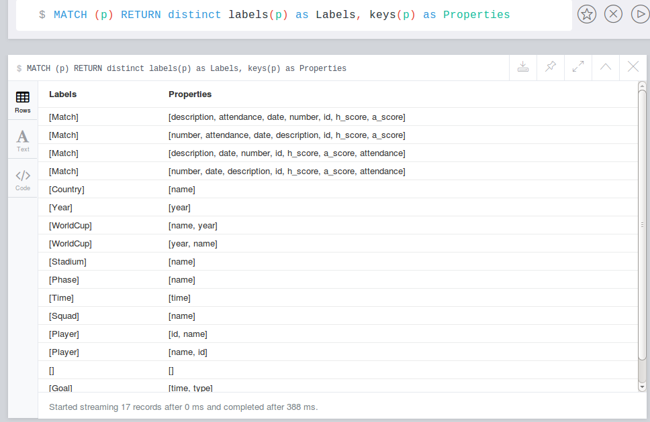

b.) Find all distinct relationship types that exist in the graph and the labels of the two (i.e.
start and end) nodes that each of the relationship connects.
MATCH (a)-[rel]-(b) return distinct type(rel) as Relation, labels(a) as Start, labels(b) as End
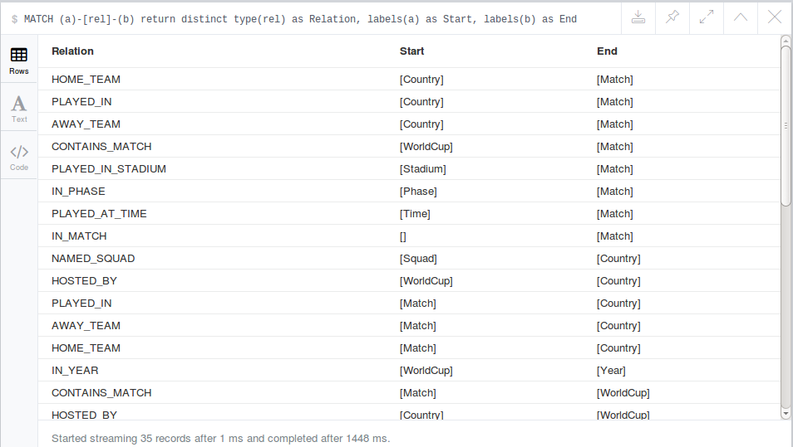
c.) Show the schema of the dataset. How many incoming and outgoing relationships does the
"Country" node have?
i) Call db.schema()
ii) MATCH ()-[in]->(x:Country), (x:Country)-[out]->() return (count(distinct type(in))+ count(distinct type(out))) as InOutRel
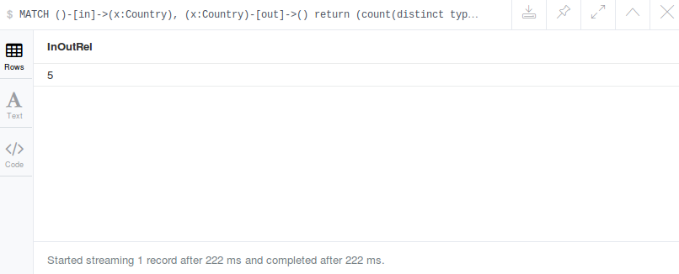
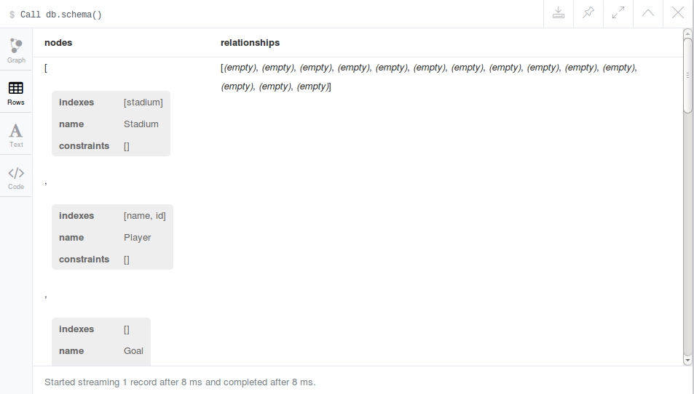
2. Data Queries
a.) How many penalty goals Gabriel Batistuta scored in WorldCups?
Match (p:Player ) -[:SCORED_GOAL]-(g:Goal)
Where p.name= "Gabriel Batistuta" AND g.type = "penalty"
Return p.name as PlayerName, count(*) as PenaltyScored

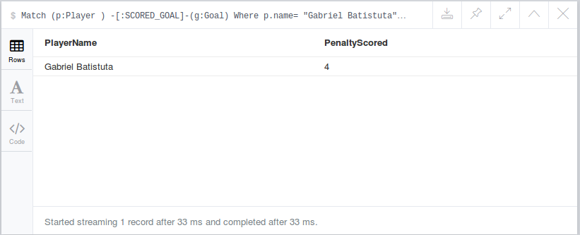

b.) Which players were teammates of Ronaldo in WorldCups (i.e. played in the same squad
as him) and in which years?
Match (a:Player)-[:IN_SQUAD]→(team:Squad)<-[:IN_SQUAD]- (b:Player), (team:Squad)- [:FOR_WORLD_CUP]->(time:WorldCup)
Where a.name = "Ronaldo"
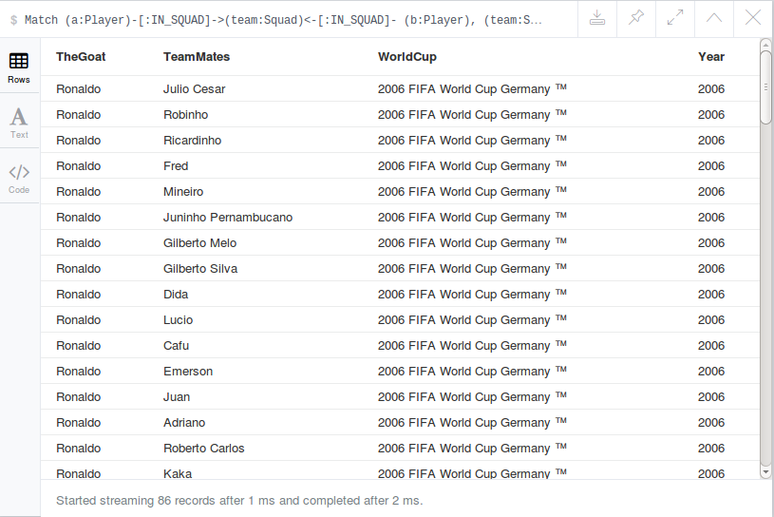
Return a.name AS TheGoat, b.name AS TeamMates, time.name as WorldCup, time.year as Year

c.) Find all the stadiums in which Brazil played against England. Also show the dates of
these matches.
Match (team1:Country)-[:PLAYED_IN]->(x:Match)<-[:PLAYED_IN]-(team2:Country), (x:Match)-[:PLAYED_IN_STADIUM]->(loc:Stadium)
Where team1.name="Brazil" AND team2.name="England"
Return team1.name as Team1, team2.name as Team2, x.date as MatchDate, loc.name as Stadium
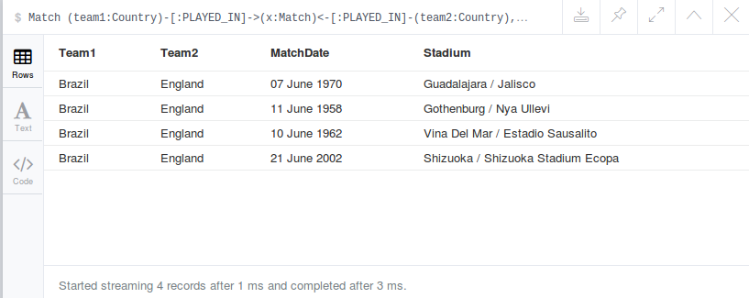
d.) Find the teams that were in the "Final" phase of the WorldCups in ascending order based
on the WorldCups name. The results should have the following titles: Home team, Away
Team, WorldCup name.
Match (x:Match)-[IN_PHASE]→(stage:Phase),(team2:Country)<-[AWAY_TEAM]-(x:Match)- [HOME_TEAM]->(team1:Country), (x:Match)←[CONTAINS_MATCH]- (WorldCup:WorldCup)
Where stage.name="Final"
Return team1.name as HomeTeam ,team2.name as AwayTeam,WorldCup.name as WorldCupName
Order By WorldCup.name ASC
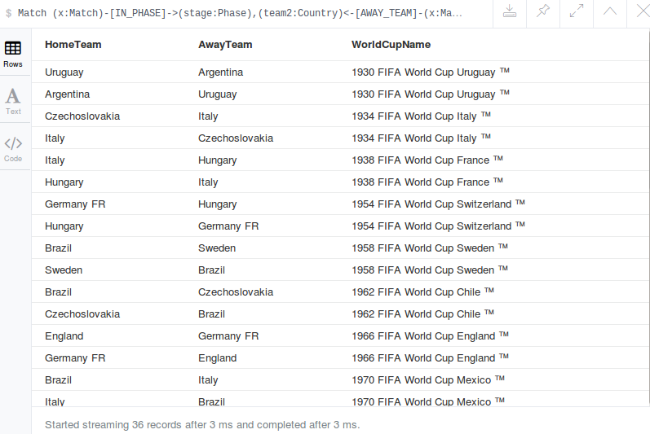
e.) Find the 5 players that scored the most goals in all WorldCups. Tip: You should consider the both goal types: penalty and goal.?

Match (p:Player)-[:SCORED_GOAL]-(g:Goal)
Return p.name as Player, count(g.type) as ScoredGoals
Order By ScoredGoals desc limit 5
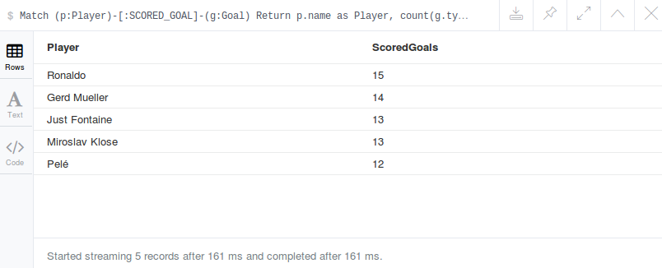
f.) Which WorldCup (i.e. year) had the most goals scored and how many?
Match (p:Player)-[:IN_SQUAD]→(:Squad)-[FOR_WORLD_CUP]→(WorldCup:WorldCup), (p:Player)-[:SCORED_GOAL]->(g:Goal)
Return WorldCup.name as WorldCup, count(g.type) as NoOfGoals
Order By NoOfGoals desc limit 1
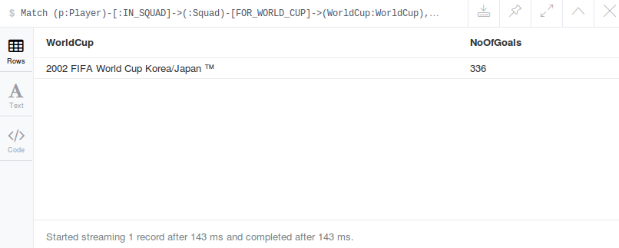
Tip: Properties are of type string. To add two numeric properties convert each into int
using toInt()

g.) Find the players who played for two or more different countries in different WorldCups.
Match (a:Player)-[:IN_SQUAD]→(:Squad)<-[:NAMED_SQUAD]-(team1:Country),(b:Player)- [:IN_SQUAD]->(:Squad)<-[:NAMED_SQUAD]-(team2:Country)
Where a.name=b.name and team1.name<>team2.name
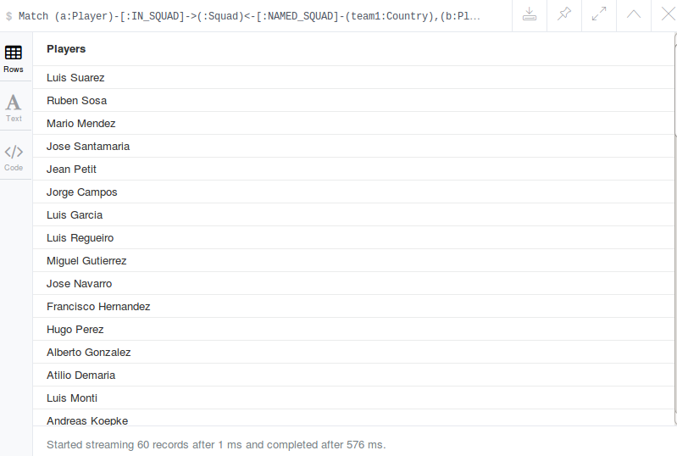
Return distinct a.name as Players

